Publication Details

1. **Full name of International Journal:** METSZET JOURNAL
2. 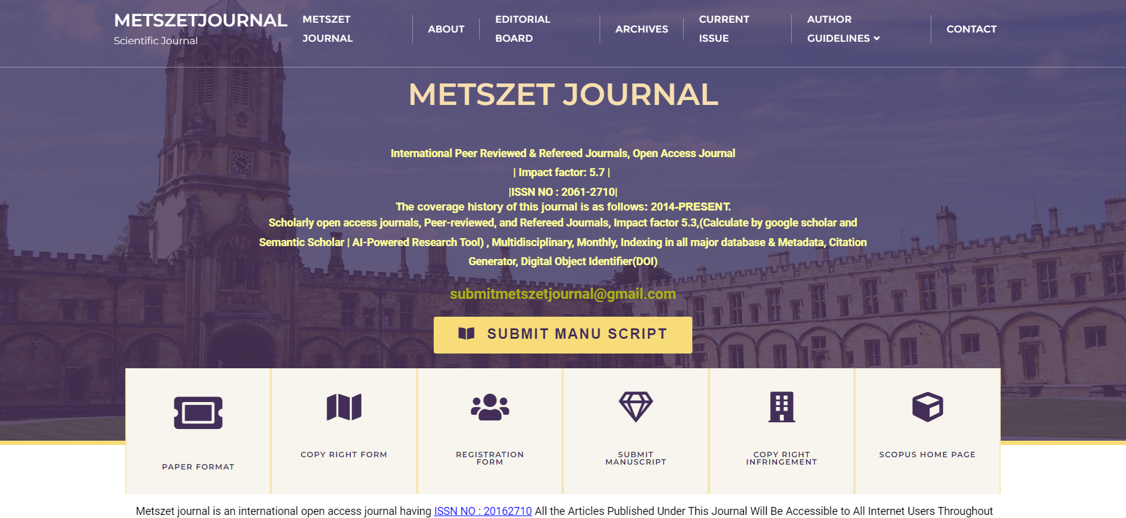**Screenshot of the home page of the journal which must include the proof of UGC approved/UGC care list/Scopus indexed journal:**
3. **Plagiarism report:**
4. **Date of paper published, ISSN no., Volume No., Issue no.:**